1. To create a New Project:
   * Open Visual Studio
   * New Project (File/New/Project)
   * Native (Templates/Cobol/Native)
   * Micro Focus INT/GNT
   * Fill in the project name (CBLXXX00)
   * Browse for the path to save projects (C:/Cobol/)
   * OK

--------------------------------------------------------------------------------------------------------

**1st Time only instructions:**

* + 1. Chose to activate the free product and use your school email
    2. Click Activate License

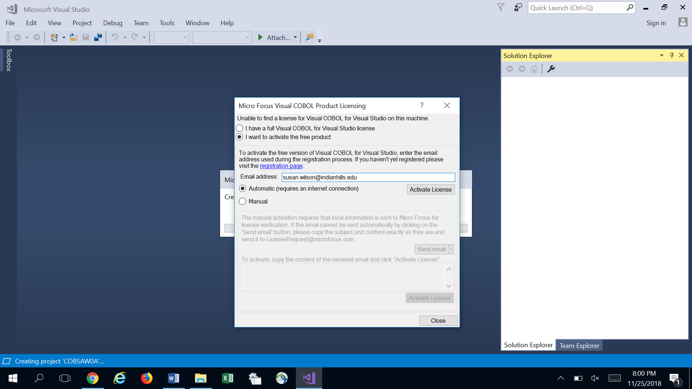

**Click close when you receive the following:**

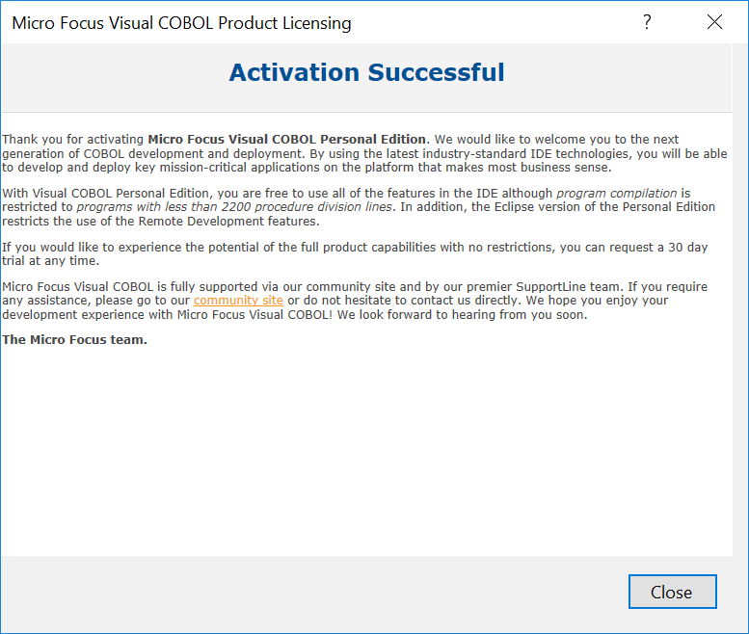

-------------------- **End First Time instructions** ------------------------------------------

1. To Create a Program within the project:
   * Click on Project on top menu bar
   * Add new item
   * Cobol Items
   * Native
   * Cobol Program
   * Name program at bottom of screen (CBLXXX00.CBL
   * ADD